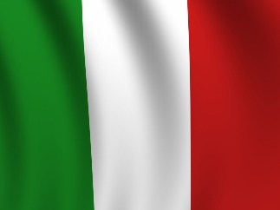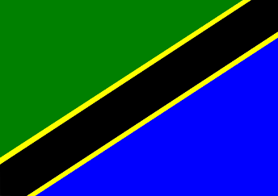
International Day 2018

The students are studying the following countries:

Class: Country:

Ms. Ginny and Ms. Pam Denmark
Ms. Shannon and Ms. Dana Madagascar
Ms. Ana Maria and Ms. Valerie Ireland
Ms. Angie and Ms. Carolina Switzerland
Ms. Dolores and Ms. Anna South Africa
Ms. Maggie and Ms. Stefanie Ukraine
Ms. Rebecca and Ms. Kaitlin Ancient China

We believe in exploring other cultures to create peace and understanding in our world. The students have had a wonderful time learning about the language, food, clothing, music and history of these countries.

They look forward to sharing what they have learned on February 22(toddler and primary), and February 23 (Elementary)

