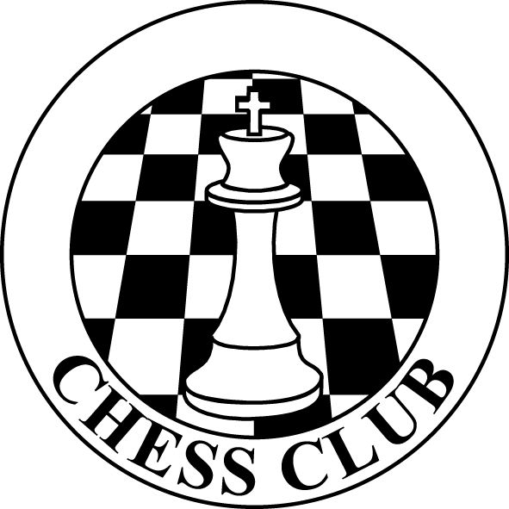 C H E S S C L UB
Chess Club will begin 2018 Session.
New students (third year primary and above) are welcome! Class
meets in the nap room (formerly Ms. Shannon’s Classroom
Child’s name: ________________________________________
Parents’ name(s): ________________________________________
Phone #: ________________________________________
Email: ________________________________________
Class Dates
August the 31st
September the 7th, 14th, 21st, and 28th

October the 5th, 12th, 19th, and 26th

November the 2nd, 9th and 16th

12 weeks
Please circle which group pertains to your child
Group I (mainly for beginners and younger students)
3:15 to 4:00 PM each Friday
$96 for 12 sessions
Group II (more advanced students)
4:00 to 5:00 PM each Friday
$120 for 12 sessions
Payments should be included in this registration
Checks should be made out to Lee Miller
**If you are unsure which group your child should be in, register for the same as last time and Mr. Miller can change placement if necessary.

