YMCA lil’ Gunners Preschool Soccer Program
Soccer for boys & girls that focuses on introducing the sport through outrageously
Fun games and activities! The ultimate goal is to inspire the players to begin to use their feet, play within a group and get some good exercise! We have spring and fall programs at preschools and at YMCA Grizzard Park, home of the YMCA Arsenal Rome Soccer Club.

For ages 3-5. 6-week program
Mondays Sept 10 – Oct 22
After School at 2:50 to 3:25 on the upper Elementary Playground

Cost: YMCA Members: $40, Potential Members: $60

*Price includes an YMCA lil’ Gunners team shirt and a medal for the completion of
the soccer training “season”.
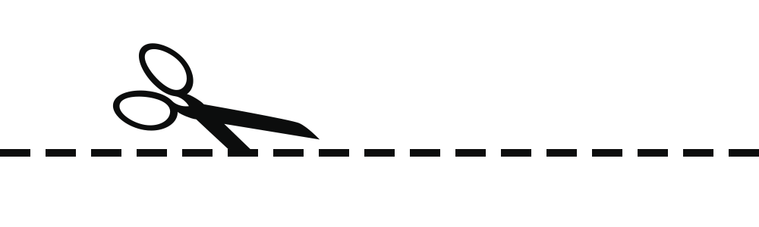
*Clinic is limited to 15 participants in each group/season. Please leave this form and payment with Montessori administration offices.
Rome-Floyd YMCA
Lil’ Gunners Preschool
Soccer Registration Form

Participant’s Name:______________________________________;____________________________
Parent Name:____________________________________________;______________________
Phone (cell preferably):________________________________:______________________________
Email:____________________________________________________:______________
*We will send out an informational text once registration has closed so if possible please provide phone number that has texting available.
*Please make all checks payable to the Rome-Floyd YMCA and attach to this form. Thank you for participating and if you have any questions contact YMCA lil’Gunners Preschool Soccer Dir. Chase Watterson, 706.506.3562, cwatterson@ymcarome.org

